Team Handball Basic Rules
.
The Ball: Team handball is played with a 32-panel leather ball that looks like a mini soccer ball.
Number of Players: There are seven players on each team (six court players and one goalie. .Positions include: left wing, circle runner, right wing, left backcourt, center and right backcourt.
- Both wings move quickly down court and usually feed the ball to the center and backcourt players (backs).
- The circle runner needs to be energetic and usually sets picks or screens. Players cannot use their arms to screen for the wings or backs.
- All players may be shooters.
How the game is played:
Throw-Off: A throw-off is taken by the team that wins the coin toss or rock paper scissors, and chooses to start the game with the ball. Each team must be in its own half of the court with the defense 3 meters away from the ball. Following a whistle, the ball is passed from center court to a teammate and play begins. Throw-off is repeated after every goal scored and after half-time.
Scoring: A goal is scored when the entire ball crosses the goal line inside the goal. A goal may be scored from any throw (free-throw, throw-in, throw-off or goal-throw).
Passive Play: It is illegal to keep the ball in a team's possession without making a recognizable attempt to attack and to try to score. In other words, a team cannot stall (free-throw awarded to the other team).
Playing the Ball
A player is allowed . . . -To run with the ball for 3 steps -To hold the ball for 3 seconds -Unlimited dribble with 3 steps allowed before and after dribbling (no double-dribble).
A player is NOT allowed . . .
- To endanger an opponent with the ball.
- To pull, hit or punch the ball out of the hands of an opponent.
- To contact the ball below the knee.
- To dive on the floor for a rolling or stationary ball.

Defending the Opponent: A player is allowed to use the torso of the body to obstruct an opponent with or without the ball. However, using the outstretched arms or legs to obstruct, push, hold, trip or hit is NOT allowed. The attacking player is not allowed to charge into a defensive player.
Throw-In: A throw-in is awarded when ball goes out of bounds on the sideline or when the ball is last touched by a defensive player (excluding the goalie) and goes out of bounds over the endline. The throw-in is taken from the spot where the ball crossed the sideline, or if it crossed the endline, from the nearest corner. The thrower must place one foot on the sideline to execute the throw. All opposing players must stay 3 meters away from the ball.
Free-Throw: For a minor foul or violation, a free-throw is awarded to the opponent at the exact spot it took place. If the foul or violation occurs between the goal area line and the 9-meter line, the throw is taken from the nearest post outside the 9-meter line. The thrower must keep one foot in contact with the floor, then pass or shoot.
7-Meter Throw aka Penalty Shot: The 7-meter throw is awarded when . . .
- A foul destroys a clear chance to score
- The goalie carries the ball back into his or her own goal area
- A court player intentionally plays the ball to his or her own goalie in the goal area and the goalie touches the ball
- A defensive player enters his or her goal area to gain an advantage over an attacking player in possession of the ball.
All players must be outside the free-throw line when the throw is taken. The player taking the throw has 3 seconds to shoot after referee's whistle. Any player may take the 7-meter throw.
Goal-Throw: A goal-throw is awarded when . . . The ball rebounds off the goalkeeper over the endline The ball is thrown over the endline by the attacking team.

Team Handball Officiating Calls and Hand Signals

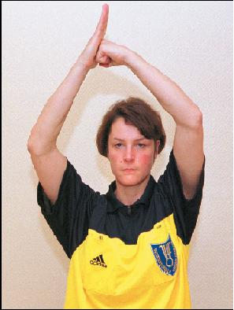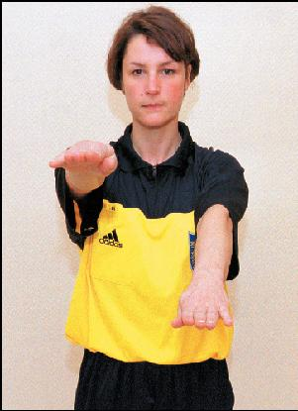
Offensive Foul Illegal Dribble

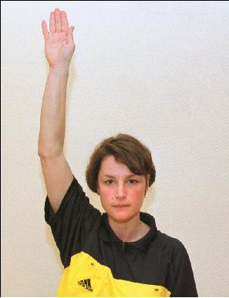 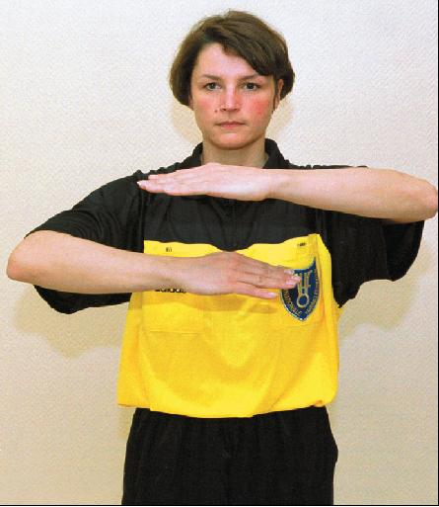 Traveling Team Handball Goal

